

AMERICAN INTERNATIONAL UNIVERSITY–BANGLADESH (AIUB)
Dept. of Computer Science
Faculty of Science and Technology
CSC 2210: OBJECT ORIENTED PROGRAMMING 2
Fall 2025-2026
Section: AA
Group No: 04

Project Report On
Gym Management System (GreyGym)
Supervised By
WAHIDUL ALAM RIYAD

Submitted By:
Name | ID
1.Adnan Akib | 23-53177-3
2. Arnab Ameer | 23-51169-1
3. Rahul Sarker | 23-51556-2
4.

CO2: Display and verify the mean of a real-life Project using the concepts of C# Graphical User Interface based environment with database integration to depict a desktop-based application.
Assessment  Criteria | Not Attended/ Incorrect (0) | Inadequate  (1-2) | Average  (3) | Good  (4) | Excellent  (5)
Evaluation Criteria | Evaluation Definition |  |  |  | Total =
Requirement fulfillment | Properly demonstrate a real-life scenario-based project with proper functional requirement identification for the Object-Oriented Programming project development activities.
Validation | Ensuring the ability of students’ proper demonstration on validation forms in their system in terms of dealing with the data.
Verification | Identifying if the students can verify the system data along with proper functional requirements in terms of data flow.

Table of Contents

1. INTRODUCTION 3
2. FEATURE LIST 4
2.1 User 1 4
2.2 User 2 4
2.3 User 3 4
3. ER DIAGRAM 5
3.1 Normalization 5
3.2 Finalization 5
4. UML DIAGRAM 6
4.1 Use Case Diagram 6
4.2 Activity Diagram. 6
5. CONCLUSION 7

INTRODUCTION

The Gym Management System is a tool that helps make running a gym easier. It is a place where people can manage lots of things. This makes it easy for customers and trainers and employees and people in charge to work together. The Gym Management System is made to help gym owners and staff with things like memberships and payments and workouts and diet plans and who trains with who. This helps the gym run better. Makes customers happy, with the Gym Management System.

The system makes it easy for customers to look at the gym packages that are available like the Standard package, the student package and the Premium package. Customers can pick the one they want and pay for it in a few ways. They can also get workout and diet plans that're just for them. When the payment is done the customer gets a trainer. The trainer then makes a workout routine and diet plan for the customer based on what they want to achieve with their fitness, such as losing weight gaining muscle or just being healthier. The gym packages, like the Standard, Student and Premium packages are all part of this process.

The system makes it easier for employees and admins to manage user information, payment verification, package subscriptions and equipment incidents. Admins have to do a few things like assign trainers to customers and make sure all plans are generated and updated for the users, which is a big part of the system, for employees and admins.

With features such as real-time updates on payments, trainer assignments, and personalized plans, the Gym Management System offers a seamless, efficient way to enhance the user experience. It eliminates manual tasks, reduces administrative overhead, and provides a user-friendly interface for both staff and customers, ensuring a more organized and effective management of gym activities.

FEATURE LIST:

Features Available to Admin:

- Manage Users:
  - Admins can add, update, or remove users from the system, including customers, trainers, and employees.
  - Admin can manage user details, such as personal information, contact details, and user type (trainer, customer, admin, and employee).
- Manage Packages:
  - Admins have the ability to create, update, or delete gym packages. They can set package details such as duration, price, and description.
  - They can also offer different membership tiers like Standard, Student, and Premium packages to cater to various customer needs.
- Verify and Confirm Payments:
  - The Admin is responsible for verifying payments made by customers for their selected gym packages.
  - After confirming the payment, Admin updates the payment status to "Confirmed" and ensures that all records are accurate.
- Assign Trainers to Customers:
  - Once a customer’s payment is confirmed, the Admin can assign a trainer to the customer based on their needs and goals (weight loss, muscle gain, fitness maintenance).
  - They link the trainer ID to the user ID, ensuring that the customer receives a personalized fitness plan.
- Monitor and Generate Reports:
  - Admin can generate various reports to track gym activities, including user statistics, payment status, and incident reports related to gym equipment.
  - Admin can review payment histories and incident reports to ensure everything is functioning smoothly.
- View and Manage Gym Equipment:
  - Admin can view and update the status of the gym's equipment.
  - Admin are also responsible for tracking any incidents or maintenance requests related to equipment, ensuring safety and functionality.
- User Access Control:
  - Admin can control access to the system by setting permissions for other users (trainers, employees). This ensures that only authorized personnel can access sensitive information and make changes.

User 2

User 3

ER DIAGRAM
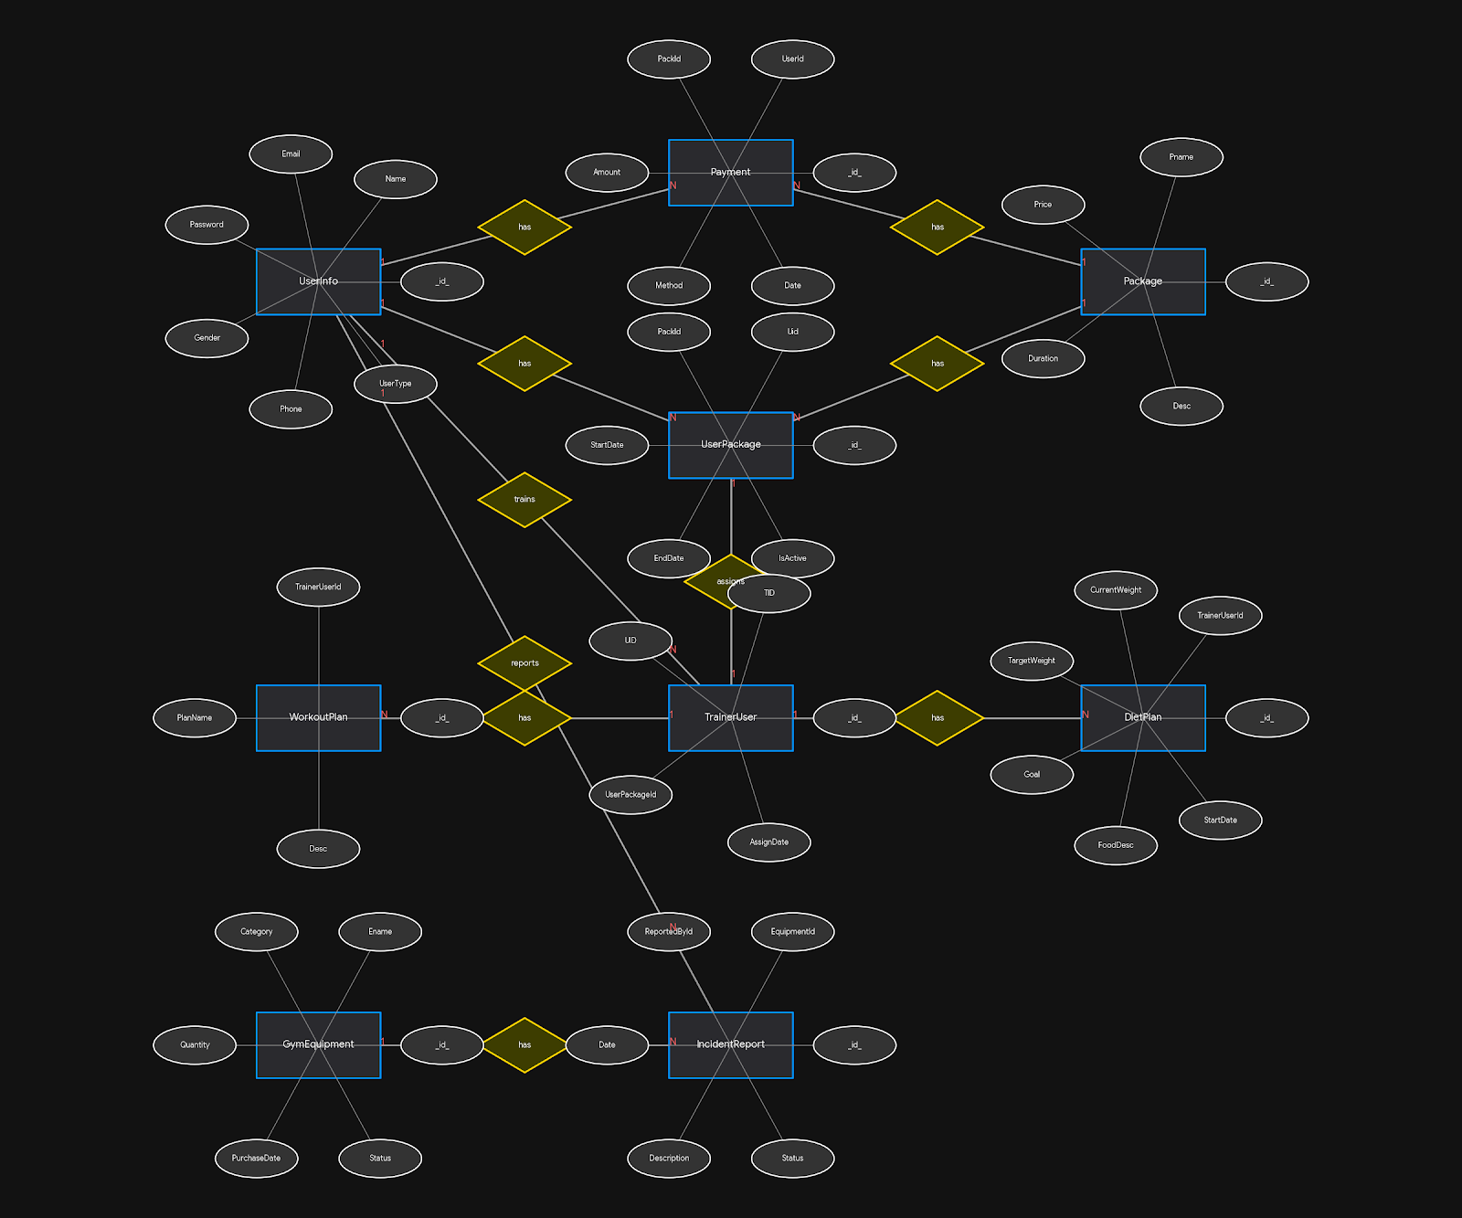

Description of the ER Diagram :

- Entities:
- UserInfo: Stores user details such as user ID, name, email, password, phone, gender, and user type (admin, trainer, customer).
- Payment: Contains payment information, including payment ID, user ID (foreign key), package ID (foreign key), amount, payment method, and date.
- Package: Represents different gym packages, storing package ID, name, price, duration, and description.
- UserPackage: Tracks the relationship between users and the packages they purchase, including start date, end date, and status.
- TrainerUser: Associates a trainer with a customer, including trainer ID, customer ID, and assignment details.
- WorkoutPlan: Stores workout plans assigned to users, including workout name and description.
- DietPlan: Stores diet plans, including current weight, target weight, goal, food description, and start date.
- GymEquipment: Represents gym equipment, with details like equipment ID, name, category, quantity, purchase date, and status.
- IncidentReport: Tracks incidents related to gym equipment, including report ID, equipment ID, reported by, date, description, and status.
- Relationships:
- UserInfo ↔ Payment: A user can have multiple payments.
- UserInfo ↔ UserPackage: A user can be associated with multiple packages.
- Package ↔ UserPackage: A package can be associated with multiple users.
- TrainerUser ↔ UserInfo: Each trainer is associated with a specific user (customer).
- TrainerUser ↔ WorkoutPlan and DietPlan: A trainer can generate multiple workout and diet plans for users.
- GymEquipment ↔ IncidentReport: Equipment can have multiple incident reports.

1NF Tables
- UserInfo
  - User_ID (Primary Key)
  - User_Name
  - User_Email
  - User_Password
  - User_Gender
  - User_Phone
  - User_Type
- Payment
  - Payment_ID (Primary Key)
  - User_ID (Foreign Key)
  - Package_ID (Foreign Key)
  - Payment_Amount
  - Payment_Method
  - Payment_Status
- Package
  - Package_ID (Primary Key)
  - Package_Name
  - Package_Duration (Months)
  - Package_Price
  - Package_Desc
- DietPlan
  - Diet_ID (Primary Key)
  - TrainerUser_ID (Foreign Key)
  - Current_Weight
  - Target_Weight
  - Goal
  - Food_Description
  - StartDate
- WorkoutPlan
  - Workout_ID (Primary Key)
  - TrainerUser_ID (Foreign Key)
  - PlanName
  - Description
- TrainerUser
  - TrainerUser_ID (Primary Key)
  - Trainer_ID (Foreign Key)
  - Client_ID (Foreign Key)
  - CustomerName
  - AssignDate

- UserPackage
  - UserPackage_ID (Primary Key)
  - User_ID (Foreign Key)
  - Package_ID (Foreign Key)
  - StartDate
  - EndDate
  - IsActive
- GymEquipment
  - Equipment_ID (Primary Key)
  - Equipment_Name
  - Equipment_Category
  - Equipment_Quantity
  - Equipment_PurchaseDate
  - Equipment_Status
- IncidentReport
  - Report_ID (Primary Key)
  - Equipment_ID (Foreign Key)
  - ReportedBy_ID (Foreign Key)
  - Report_Date
  - Report_Description
  - Report_Status

2NF Table
- UserInfo
  - User_ID (Primary Key)
  - User_Name
  - User_Email
  - User_Password
  - User_Gender
  - User_Phone
  - User_Type
- Package
  - Package_ID (Primary Key)
  - Package_Name
  - Package_Duration (Months)
  - Package_Price
  - Package_Desc
- Payment
  - Payment_ID (Primary Key)
  - User_ID (Foreign Key)
  - Package_ID (Foreign Key)
  - Payment_Amount
  - Payment_Method
  - Payment_Status
- DietPlan
  - Diet_ID (Primary Key)
  - TrainerUser_ID (Foreign Key)
  - Current_Weight
  - Target_Weight
  - Goal
  - Food_Description
  - StartDate
- WorkoutPlan
  - Workout_ID (Primary Key)
  - TrainerUser_ID (Foreign Key)
  - PlanName
  - Description
- TrainerUser
  - TrainerUser_ID (Primary Key)
  - Trainer_ID (Foreign Key)
  - Client_ID (Foreign Key)
  - CustomerName
  - AssignDate
- UserPackage
  - UserPackage_ID (Primary Key)
  - User_ID (Foreign Key)
  - Package_ID (Foreign Key)
  - StartDate
  - EndDate
  - IsActive
- GymEquipment
  - Equipment_ID (Primary Key)
  - Equipment_Name
  - Equipment_Category
  - Equipment_Quantity
  - Equipment_PurchaseDate
  - Equipment_Status
- IncidentReport
  - Report_ID (Primary Key)
  - Equipment_ID (Foreign Key)
  - ReportedBy_ID (Foreign Key)
  - Report_Date
  - Report_Description
  - Report_Status

Final Tables (3NF):
- UserInfo
  - User_ID (Primary Key)
  - User_Name
  - User_Email
  - User_Password
  - User_Gender
  - User_Phone
  - User_Type
- Package
  - Package_ID (Primary Key)
  - Package_Name
  - Package_Duration (Months)
  - Package_Price
  - Package_Desc
- UserPackage
  - UserPackage_ID (Primary Key)
  - User_ID (Foreign Key)
  - Package_ID (Foreign Key)
  - StartDate
  - EndDate
  - IsActive
- Payment
  - Payment_ID (Primary Key)
  - User_ID (Foreign Key)
  - Package_ID (Foreign Key)
  - Payment_Amount
  - Payment_Method
  - Payment_Status
  - Payment_Date
- TrainerUser
  - TrainerUser_ID (Primary Key)
  - Trainer_ID (Foreign Key)
  - Client_ID (Foreign Key)
  - AssignDate
- DietPlan
  - Diet_ID (Primary Key)
  - TrainerUser_ID (Foreign Key)
  - Current_Weight
  - Target_Weight
  - Goal
  - Food_Description
  - StartDate
- WorkoutPlan
  - Workout_ID (Primary Key)
  - TrainerUser_ID (Foreign Key)
  - PlanName
  - Description
- GymEquipment
  - Equipment_ID (Primary Key)
  - Equipment_Name
  - Equipment_Category
  - Equipment_Quantity
  - Equipment_PurchaseDate
  - Equipment_Status
- IncidentReport
  - Report_ID (Primary Key)
  - Equipment_ID (Foreign Key)
  - ReportedBy_ID (Foreign Key)
  - Report_Date
  - Report_Description
  - Report_Status

UML DIAGRAM

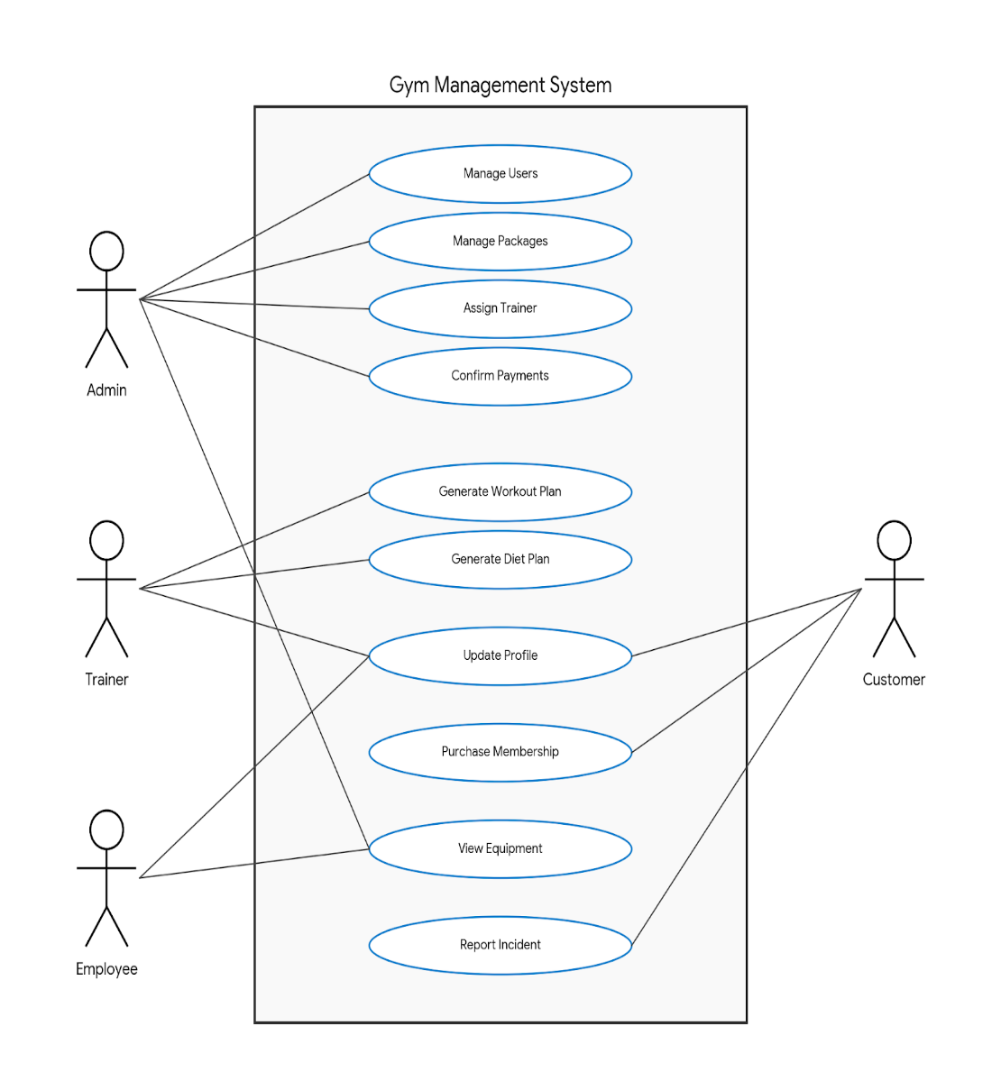
Use Case Diagram

- Description of the Use Case Diagram:
- Admin:
  - Manages users (e.g., adding, updating, and deleting user accounts).
  - Manages gym packages (e.g., creating or updating membership packages).
  - Assigns trainers to customers (e.g., matching customers with trainers).
  - Confirms payments made by customers.
- Trainer:
  - Generates workout plans for customers based on their fitness goals.
  - Generates diet plans tailored to each customer.
  - Updates the customer's profile, including progress and feedback on their workouts and diet plans.
- Customer:
  - Updates their profile information.
  - Purchases a gym membership.
  - Views gym equipment availability.
  - Reports incidents (e.g., damaged or malfunctioning equipment).
- Employee:
  - Views available equipment.
  - Reports incidents to the system.

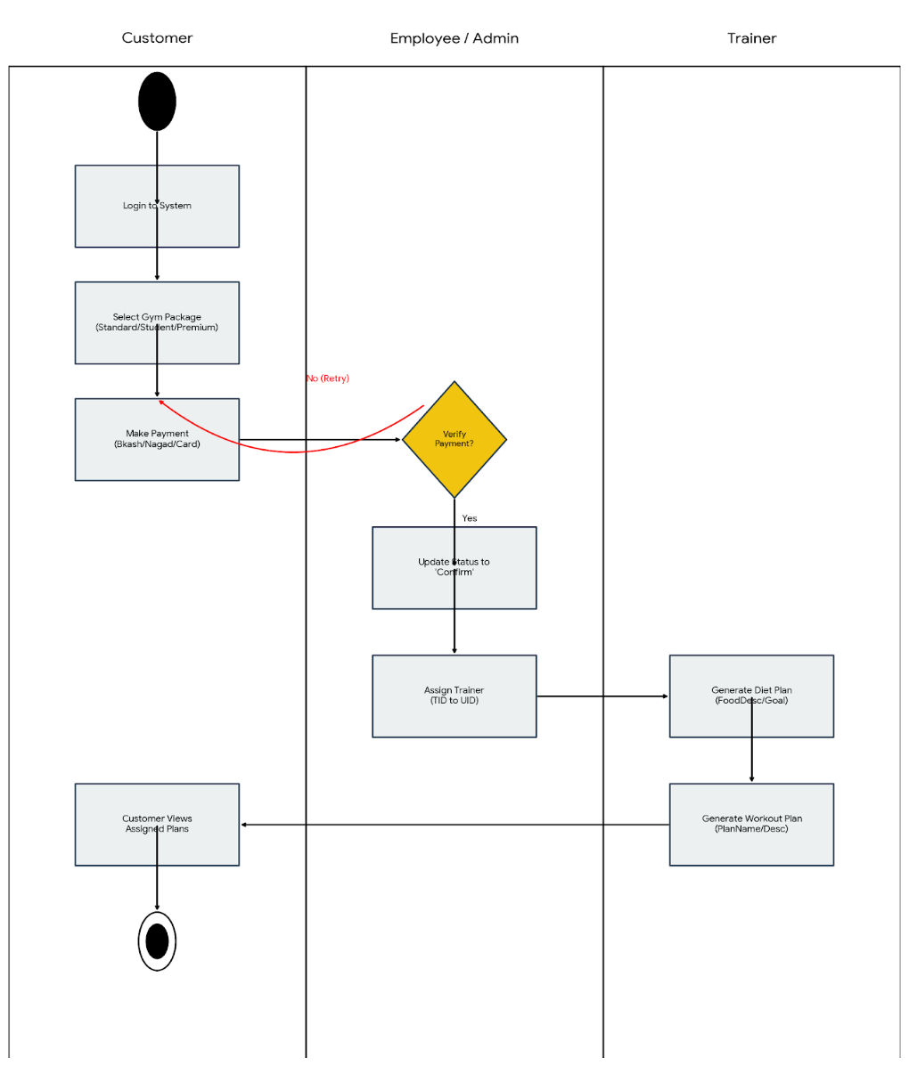
Activity Diagram.
Along with diagram description

Description of the Activity Diagram:

1. Customer:
- Login to System: The customer logs into the system to access gym services.
- Select Gym Package: The customer selects a gym package (Standard, Student, or Premium) based on available options.
- Make Payment: The customer proceeds to make a payment, selecting a payment method (cash, card, or bank transfer).
2. Employee/Admin:
- Verify Payment: The employee or admin verifies the payment made by the customer.
  - If payment is not verified, the process will loop back, and the customer will be asked to retry the payment.
  - If payment is verified, the employee/admin updates the payment status to "Confirmed."
- Assign Trainer: After confirming the payment, the employee/admin assigns a trainer to the customer (Trainer ID linked to User ID).
3. Trainer:
- Generate Diet Plan: The trainer generates a diet plan for the customer based on their goals, such as weight loss or muscle gain (food description and goal).
- Generate Workout Plan: The trainer also generates a workout plan with the details of the exercises and descriptions.

4. Customer (After Payment Confirmation):
- Customer Views Assigned Plans: Once the payment is confirmed and the trainer is assigned, the customer can view their assigned workout and diet plans.

CONCLUSION

The Gym Management System is a powerful tool designed to make the day-to-day operations of a gym much smoother and more efficient. By automating processes like user registration, payment management, trainer assignments, and plan creation, the system helps reduce the administrative burden and ensures everything runs without a hitch. As part of my gym project, this system allows the admin to easily manage users, confirm payments, and assign trainers, while trainers can quickly generate customized workout and diet plans for their clients.

For customers, it’s a simple and seamless experience to choose a gym package, make payments, and access personalized fitness plans. Ultimately, this system not only enhances efficiency within the gym but also improves the overall experience for both staff and members. It supports the gym’s growth by keeping everything organized, timely, and accessible—creating a better environment for fitness, progress, and success.

Text Format:
- Style: Times New Roman
- Size: 12
- Space: 1.0
- Alignment: Justify
- Delete this part after completing your report

